GRIEVANCE REDRESSAL SYSTEM

A Project Report
Submitted in partial fulfilment for the award of the degree
of
Master in Computer Application
by
Name- ____________
Reg.no-XXXXXXXX

Under the guidance of
***************
Head of the Department,
Master in Computer Application



Reference no:
Date:

Certificate

This is to certify that the project report entitled “GRIEVANCE REDRESSAL SYSTEM” submitted by Mr._______________,(XXXXXXXXX) is an authentic work carried out by him at IMIT under my guidance. The matter embodied in this project work has not been submitted earlier for the award of any degree or diploma to the best of my knowledge and belief.

*****************
(Guided By)
Examined by: (Prof. )
(External Supervisor)

COMPANY CERTIFICATE

COMPANY CERTIFICATE

COMPANY CERTIFICATE

DECLARATION

I hereby declare that the thesis entitled “GRIEVANCE REDRESSAL SYSTEM” submitted by me to Institute of Management and Information Technology, Cuttack, Odisha in partial fulfilment of the requirement for the award of the degree of Master in Computer Application is a record of bonafide project work carried out by me under the supervision of ***************, Head of Department(MCA). I further declare that the work reported in this project has not been submitted and will not be submitted, either in part or in full, for the award of any other degree or diploma in this institute or any other institute or university.

Place:
Date: Signature of the Candidate.

ACKNOWLEDGEMENT

The satisfaction that accompanies the successful completion of any task would be in complete without the mention of people whose constant guidance and encouragement crowns all efforts with success. The acknowledgement would like to express deep gratitude respect to all those people behind the screen who guided inspired and helped me for the completion of my project work.
I also take this opportunity to thank ***************, head of Department, MCA, for his constant support and timely advice.
I would like to express my deep sense of gratitude towards my guided teacher **************, head of MCA Dept. for their sincere guidance, valuable suggestion and constant encouragement during the preparation of the projects report. Thanking All.

TABLE OF CONTENTS
CHAPTER NO. | TITLE | PAGE NO.
 | ABSTRACT | I
 | LIST OF TABLES | II
 | LIST OF FIGURES | III
 | LIST OF ABBREVIATIONS | III
Chapter 1 | CHAPTER-1
 | 1.1 Introduction | 1
 | 1.2 Problem Statement | 2
 | 1.3 Objective and scope | 2
 | 1.4 Existing System | 3
 | 1.5 Proposed System | 3
 | 1.6 Technologies | 4
Chapter 2 | CHAPTER-2
 | 2.1 Literature Survey | 5
 | 2.2 Methodology | 6
 | 2.3 Gantt Chart | 9
Chapter 3 | CHAPTER-3
 | 3.1 Purpose Of The Project | 10
 | 3.2 Input And Output | 10
Chapter 4 | CHAPTER-4
 | 4.1 Introduction to System Design | 12
 | 4.2 E-R Diagram | 14
 | 4.3 DFD | 15
 | 4.4 Use Case Diagram | 16
 | 4.5 Sequence Diagram | 17
 | 4.6 Class Diagram | 20
 | 4.7 State Diagram | 21
 | 4.8 Data Dictionary | 22
Chapter 5 | Coding | 27
Chapter 6 | Testing | 34
Chapter 7 | Output Screens | 43
Chapter 8 | Conclusion And Future Work | 47
Chapter 9 | References | 48

ABSTRACT

In the current information world telecom industry are adapting online (Web based) platform for monitoring and tracking all kind of grievance activities. Since the main objective of all telecom Industry are to provide high quality services to their customers. So, for better performance monitoring student activity is an important aspect in education process.

Currently most of the educational institutes adopting manual approach to maintain records and tracking student activities. Manual approach has lot of disadvantages like its time consuming, failure to meet on demand information retrieval etc.

The proposed application “Online Monitoring of Student activities” addressing the problems of manual system. It has three Modules such as 1. Admin Module , 2. Teacher Module and 3. Student Module.

Admin Module Add/Edit/Delete New Student, New Teacher, Subject ,Prepare Time Table, Allocates Subject to Teachers , Send Notification to teacher and Students etc.

Teacher Module: Teacher login to the system, manage their profile, Add Students to the subject and takes attendance of student, Share Notes and give assignment to the student and evaluates them and also take online examination on their concerned topic by uploading question papers.

Student Module: Students login to the system, attend the class and gives attendance, download notes and and appear exam and also get their performance report.

I
LIST OF TABLES

Table no. | Table Name | Page No.
1 | Gantt Chart | 9
2 | Manual Test Case 1 – Login | 41
3 | Login Test Case 1 | 41
4 | Login Test Case 2 | 42
5 | Test Case 1 for Teacher Reg. | 42
6 | Test Case 2 for Teacher Reg. Failed | 43
7 | Test Case 1 for Student Reg. | 43
8 | Test Case 2 for Student Reg. Failed | 44
9 | Test Case for Give Feedback | 44

II
LIST OF FIGURES

Figure no | Figure name | Page no.
1 | Flow Diagram | 13
2 | ER | 14
3 | DFD | 15
4 | Use Case Diagram | 16
5 | Sequence Diagram | 19
6 | Class Diagram | 20
7 | State Diagram | 21
8 | Testing Types | 35

List of Symbols and Abbreviations
- OMSA – ONLINE MONITORING OF STUDENT ACTIVITY
- DFD – Data-FlowDiagram
- SDLC – Software Development Life Cycle
- GUI – Graphical UserInterface
- ER-Diagram – Entity RelationshipDiagram
- HTML – Hyper-Text Mark-upLanguage
- JSP- JAVA SERVER PAGES
- SQL – Structured QueryLanguage
- HTTP – Hypertext Transfer Protocol
- CSS – Cascading Style Sheets
- MVC – Model View Controller
- JSON – JAVASCRIPT OBJECT NOTATION

III

CHAPTER – 1

Introduction to Online Monitoring of Student Activity

1.1 Introduction to the Project:
“Online Monitoring of Student Activity” is software which is helpful for students as well as the school authorities. In the current system all the activities are done manually. It is very time consuming and costly. Our Student Management System deals with the various activities related to the students.
There are mainly 3 modules in this software
- Administrator Module
- Teacher Module
- Student Module.
In the Software we can register as a teacher as well as a student for every student the authentication code and the roll no is provided by the head of the department faculty and for the registration of a faculty the Registration ID and the authentication code is provided by the administrator the institute.
In this project an admin can manage the faculty and take decision about the students like deletion of any student admin is authorized to create the token for the registration of the faculty as same as a faculty is authorized for creating token for the registration of a student.

  - Problem Statement:

Using Manual System all the records related to teacher, students are maintained in different files (Excel Sheets). Teacher has to maintain all activity of the students such as attendance, class notes, assignments & exam details etc. in different files on daily basis. Admin also maintain teacher details and student details in different files. It requires more effort to maintain those files and it increases the task of the teacher and it indirectly affects the teacher performance.
Managing different files for different purpose is a complex task and files management may face problems like data loss, deletion of files, unauthorized access, security measures, synchronization problems, data redundancy, slow in retrieval of data on demand.

  - Objective and Scope:
Objective:
- To design and develop a (online monitoring student activity software for educational institute).
- To automate the classroom activity both for teacher and students.
- To implement a proper feedback system for teacher and student for better decision.
- To track the attendance of the student through online for evaluate their eligibility for different purpose
Scope:
Without a “Online Monitoring of Student Activity”, managing and maintaining the details of the student is a tedious job for any organization. “Online Monitoring of Student Activity” will store all the details of the students including their background information, educational qualifications, personal details and all the information related to their academic activities.
The main focus of this project is to manage an educational institute smoothly. By providing user friendly interfaces. The System will be administrator, teachers and students.
User can access the application through online using their laptop or mobile. Since, this project uses open-source technologies java, Mysql, etc., It is affordable for any organization.

  - Existing System
In the Existing System, the records of the educational institute are maintaining manually that is using files. Which leads to following problems:
- No proper authentication.
- No Security.
- Synchronization issues.
- Data integrity problems.
- No proper feedback system.
- No proper interface for student – teacher interaction.
- Data Redundancy occurs.
- Problems in tracking of student’s attendance properly.
- Lack of proper facility to get access to the missing class.
- Problem in sending notification for different events manually.
- Conducting of Exam, Exam evaluation and result publication is slower and inefficient.
- Getting reports for decision making may be slower.

1.5 Proposed System
In the Proposed System (“Online Monitoring of Student Activity”), we’ll get the following advantages:
- Proper authentication by providing login interface to the system.
- It provides security, no unauthorized access without proper authentication.
- Synchronization, changes at one place will reflect in every place.
- Online feedback system for student and teacher which helps the admin for taking proper decision.
- User friendly and easy interface for student – teacher interaction.
- Online attendance.
- Notes sharing facility in the system.
- Automatic notification using SMS and email.
- Online question upload and conduct of exam using the system.
- Getting reports for decision making quickly.

1.6 Technologies Used:
- Server-side Technology: J2EE (JSP, servlet, Beans, JDBC).
- Client-Side Technology: HTML, CSS, JAVASCRIPT, JQUERY, BOOTSTRAP 4, JSON.
- Web Server: Apache Tomcat
- Architecture: MVC.
- IDE: Eclipse.
- Database: MYSQL.
- Documentation: MS-WORD.
- Designing: E-DRAW.

CHAPTER – 2
System Analysis

2.1 LITERATURE SURVEY
The system has come up with many functionalities for educational institutions to monitor the student activities. It helps both student and teacher to keep track of student activities through online. It also notifies student and teacher during the time of important events which are happening in institution. One more feature is automated notification to the student whenever student get failed in the exam or student not able to meet the expected attendance average. “Online Monitoring of Student Activity”, is web application and which has intention to begin a conductive and direct interchanging the statistics in a secure platform to coalesce with students, faculties, college/school administration. OMSA application is trouble free to use in schools, colleges, universities, and any other educational institutions. It can be customized as per the need. It can be used in private and government educational institutions also. OMSA application is an internet-based application we can login to the system from anywhere irrespective of geographical area it will give seamless navigation. The paper provides the particulars to carry out the performance, management and decision-making functions of enterprises or organizations. Enormous grow of students is caused to expand the functionality in the respective educational institutions. As student added to the educational system it is difficult to manage and track student details. To overcome difficulties, we come up with this new approach OMSA with additional features. This new approach will provide fast processing, efficient student tracking, and produces desired result. This approach will allow students to save their personal details. It is more secure, reliable and easy to use. Attendance is part of any system to keep track of the particular person. It is mandatory process in educational system which directly reflects the student progress. In educational institutes attendance management is normally a manual process. There is enormous grow in the software industry which has privileged colleges to maintain the attendance system by using gadgets which is the best way. As we are using the smart phones, we not require maintaining attendance register. It can be easily done in mobile application. Faculty will be going to take the attendance when class gets started. They will initially login to the system. Once attendance has been taken successfully for the class it will sent to database. The faculties can also do the necessary functions like registering new students, deleting the information about a particular student, modifying the information regarding the student etc. The main intention of this process is to reduce the risk of manual efforts. It also reduces the time consumption. Also, we want to give importance to reduce the paper wastage that daily happens. The model [4] utilizes computer aided system. The model plays main role in an institution or in the college management. Initially, the system has developed with four layers based on the hierarchy such as Web display layer where application is deployed and displayed for end users. Business logic layer responsible for handling the functionality of the product. Data access layer is responsible for viewing the data. Database layer responsible for storing the student data. In Database layer ER diagram has been designed to provide data normalization. The process provides complete information about student, faculties and educational institution. Third thing in this project is to allowing user based on their categories. The paper provides end user to seamless navigation to the application and ease of access. The model provides information management storing of student academic reports. This model consists of various functionalities like information about the courses available in the college starting from first grade to graduation. It also enables students to enroll to particular course through online, examination results, and also get notified when important events occur. All data stored and retrieved through the application is secure. So, to achieve this we have developed a powerful web based secured interface application which supports all type of request which are coming from the students also which gathers and corrects all student information. This system is providing seamless access through the web-based application to access and manage different department or all over the organization.
2.2 METHODOLOGY

AgileMethodology
Agile SDLC methodology is a combination of iterative and incremental process models with focus on process adaptability and customer satisfaction by rapid delivery of working software product.
Agile Methods break the product into small incremental builds. These builds are provided in iterations.Eachiterationtypicallylastsfromaboutonetothreeweeks.Everyiterationinvolves cross functional teams working simultaneously on various areas like planning, requirements analysis, design, coding, unit testing, and acceptancetesting.
At the end of the iteration a working product is displayed to the customer and important stakeholders.

At a high-level, the steps in the agile model are as follows:

Steps 1 & 2: User Story Writing and Estimation

Userstoriesareuserrequirementsintheplaincustomer’slanguagewithoutincludingtoomany details. Usually User stories are written in followingformat.
As a <User> I want to <Perform a function> to <achieve something>

Someoftheuserstoriescanbehuge,andcouldbedividedintomanysmalleruserstories;those big user stories are also called “Epics” or “Features”. One Epic or Feature can have many smaller userstories.
Story Estimation

Once story is completed, it needs to be estimated, in a session with the help of the team. Participants of the story estimation team are development team members and product owner. Presence of development team is important since they can provide good feedback regarding design, development and testing activities. Product owner presence is also important because of his knowledge of business.
Story points: Story points are used as unit of estimation in agile world. Sometimes teams assigned a time frame to story point to get exact idea how much time it will take to complete the story. Sometimes team select the hours instead of story point though it's not preferred estimation unit.
The question is why we want to estimate the stories, the simple answer to this question is “to know how long would it take to complete them”, knowing the estimate is important to get an idea how many user stories can be completed within one Release.
Steps 3 & 4: Story Prioritization in the backlog

Only a set of stories are selected to be implemented in iteration. To select the stories for iteration,teamprioritizesthembasedontheirimportance,need andriskvalue.Forexample,in the start of the project user stories which are related to design will take precedence over development related user-stories. Usually, higher risk stories are also of highest priorityones.
Out of iteration stories can be prioritized and re-prioritize when needed inside the product backlog, but once added to the iteration (sprint) adding or replacing user-stories with the existing ones is not recommended.
Therearecoupleoffamoustechniquesusedtoprioritizetheuserstories.Oneofthemiscalled MoSCoW(MustShouldCouldWon't)technique.Inthismethoduserstory’spriorityisdefined by words 'must', 'should', 'could' and'won’t'.
Step 5: Release Planning

A release is a time-boxed activity in which certain high ranked user stories are set to be completed. A release planning meeting is arranged so team could see what product owner and stakeholders want to achieve in a specific time. And also gets chance to look into the vision and road map for the product. This meeting helps everyone in the team to come on the same page.Stakeholdersandproductownertransfertheirvisionandexpectationtothedevelopment team. Development team contributes in refining the concept of the project by asking more questions and in some cases providing the answers of the unknowns given by product owner or come up as a result of thediscussions.
Step 6 & 7: Sprint Planning & Task Creation Process.
The Sprint planning meeting takes place in the beginning of iteration. The development team selects a higher priority user story and divides it into one or many tasks. Tasks are createdand assigned bydevelopers.
Sameprocessisrepeatedforallthestoriesuntilcapacityoftheteamisreached.Oncecapacity is reached no more user stories are added. During the process of dividing the user stories into task, everyone in the development team collaborate and give his/her estimate to complete a task, planning poker technique can be used for that purpose. Team identifies the work to perform and commits to delivering potential product increment at the end ofiteration.
Step 8-12: Sprint Iteration

Development team works on design, development and testing activities during an iteration (sprint). Duration of a sprint varies from team to team. 1-4 weeks iteration can be selected but mostly 2 week iteration is popular in agile.
Step8-12showssprintandactivitiesperformedduringandattheendofasprint.Attheendof each sprint product output is produced and demonstrated to the customer in Sprint Review meeting. Also at the end of each sprint retrospective is performed to review the scrum process within scrumteam.

A release may consist of many sprints. Release output is a product that can be used by the customer.

Gantt Chart:

Task Name | Duration | Month-1 | Month-2 | Month-3
Task Name | Duration | W  1 W  2 W3 W  4 | W  1 W  2 W3 W  4 | W  1 W  2 W3 W  4
Requirement Gathering &Analysis | 4 Weeks
Design | 2 Weeks
Coding | 2 Weeks
Testing | 3 Weeks
Deployment &Implementation | 1 Week

Table 1: OMSA - Gantt Chart

CHAPTER – 3
3.1 Purpose of The Project:
The aim of proposed system is to develop a system of improved facilities .The proposed system can overcome all the limitations of the existing system .The System provides proper security and reduces the manual work.
- Security Of Data
- Ensure Data accuracy
- Proper control of the system
- Minimize Manual Data Entry
- Greater Efficiency
- Better Service
- User Friendliness and Interactive
- Minimum Time Required
3.2 Input and Output
The main inputs, outputs and major functions of the system are as follows
INPUTS:
• Admin/Teacher/Student enters his or her user id and password.
• Teacher /Student Give Feedback
• Teacher /Student Update Profile
• Teacher/Student Apply for Leave
• Teacher Upload Notes

OUTPUTS:
• Admin View Feedback.
• Admin View Leave Application and approve.
• Students View Notes and Exam Result.
• Teacher View Student Attendance.

CHAPTER – 4
4.1 SYSTEM DESIGN

This application is designed by using J2EE and MYSQL Database. The Front end is designed by using Bootstrap4, HTML, CSS, Jquery supported by back end as MySQL. We have used Tomcat Web Server to deploy the application. We have implemented backup strategy to restore the data which is lost accidentally. User management like password expire, password protection, password encryption will be taken care in the project.. It prevents unauthorized data access and it restrict data hacking or manipulation. In application server end user sessions will be handled.
FLOW CHART
Based on end user necessities as well as the thorough investigation on current system we have suggested a system that satisfies user requirements. Initially admin will going to login to the system. Once he successfully logged in, he will be able to upload student details and faculty details. Admin may be head of the department. And he will give access to faculties and students. Admin have the privileges to view/edit the details of both students and faculties. Also he can send the circular or the notice to all faculties and students. Also he can see the reports of the students’ and faculties. Faculty will be going to log in to the system. He can store the student attendance and internal assessment marks also he can view the same. And average of internal assessments calculated automatically. The faculty can generate report based on the student records like attendance and internal assessments. Students have to visit to the portal and need to provide the respective details, after that student will be registered. Admin will distribute the passwords to the faculties and student. Once they receive the password from the admin they are able to login to the application and monitor the statistics.
Once they receive the credentials they are able to access the application. And also to monitor the statistics like they can generate their own report of internal assessments and attendance and they can view their performance. End user will be going to login to the system. There are three types of users are created based on the access criteria. They are Admin, Faculty and Student. Admin users are responsible for storing student data and faculty details, scheduling time table for faculties. Admin users can create, replace, update, delete (CRUD) the student and faculty details.
Admin users can also generate all types of reports which are available in the application. Admin user can send circular or notice to faculties and students. Admin users will have all the privileges and access to the application. Admin user is a root user; he is having complete control over the application. Faculty users are responsible for maintaining the attendance of the students, internal assessments marks, generating time tables. Faculty users can generate report based on the student progress like internal assessment, attendance. Student users are responsible for viewing their own page; they can check their academic progress, and attendance. They are able to generate report and charts like bar/pie based on their performance. Once particular user is positively registered in, if logged in user is student then he is not authorize to make changes or manipulate the details. If logged in user is a faculty user then he can manipulate student attendance and internal assessment marks. If logged in user is an admin user then he is the only person to manipulate all the necessary details regarding students and faculties. When an admin finishes all manipulations, faculty will generate the report and he will be sending an email or SMS to the respective student’s parent.
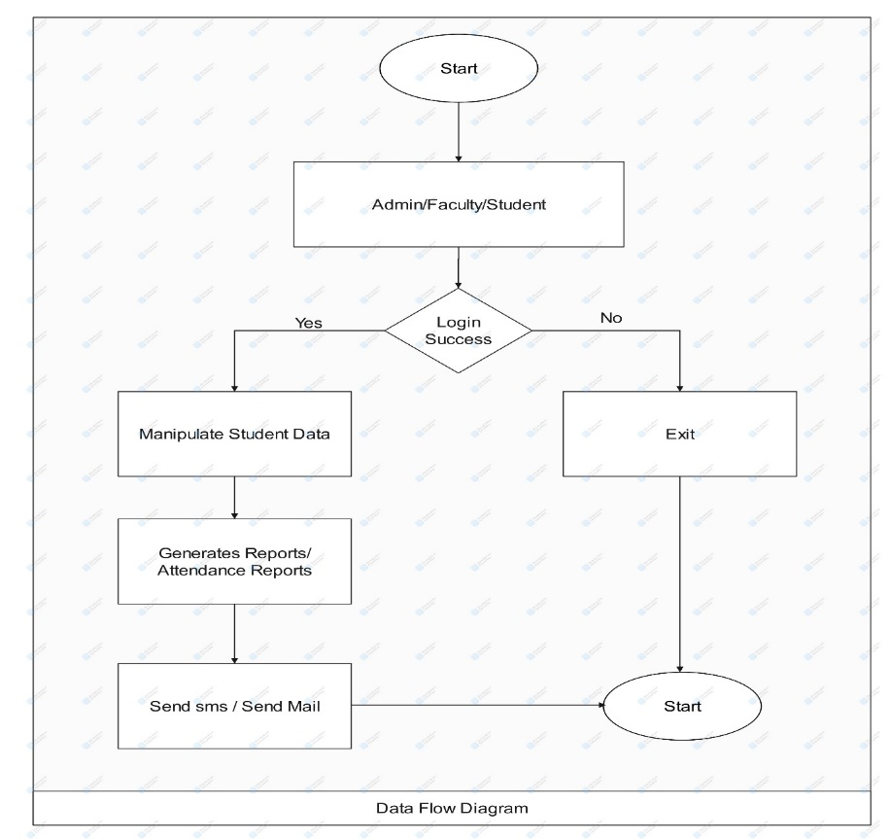

Figure 1- Flow Diagram

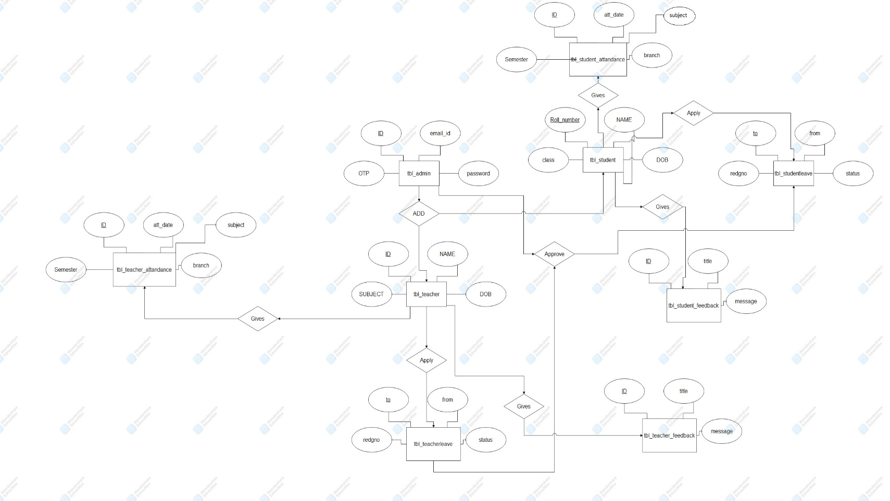
4.2 E-R Diagram

Figure 2- ER DIAGRAM

4.3 Data Flow Diagrams
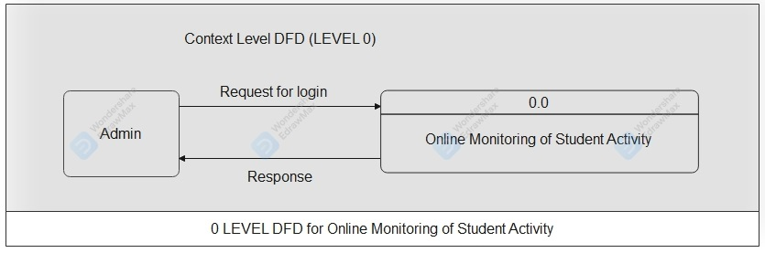

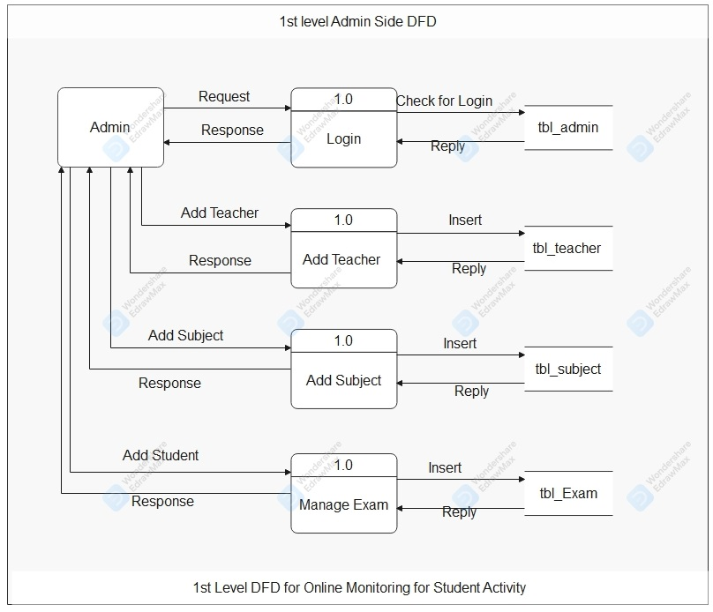
Figure 3- Data Flow Diagram
4.4 Use Case Diagram:
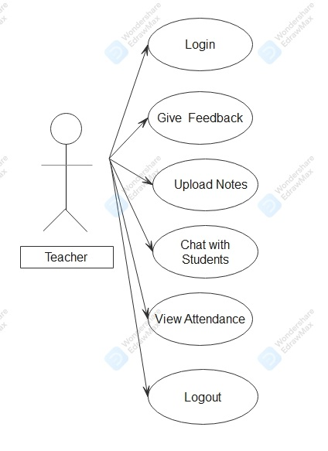
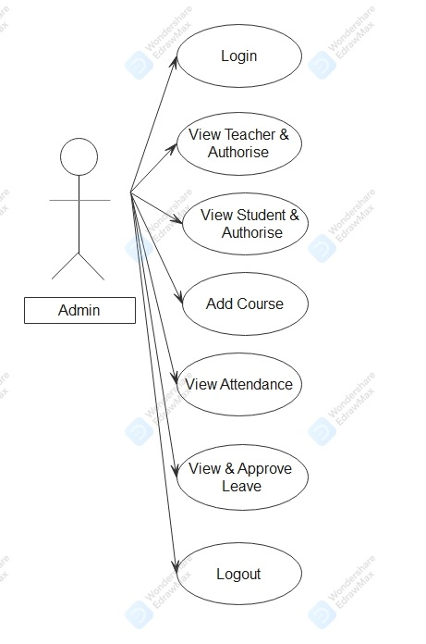

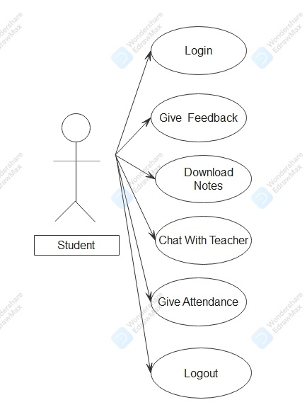

Figure 4- Use Case Diagrams
4.5 Sequence Diagram

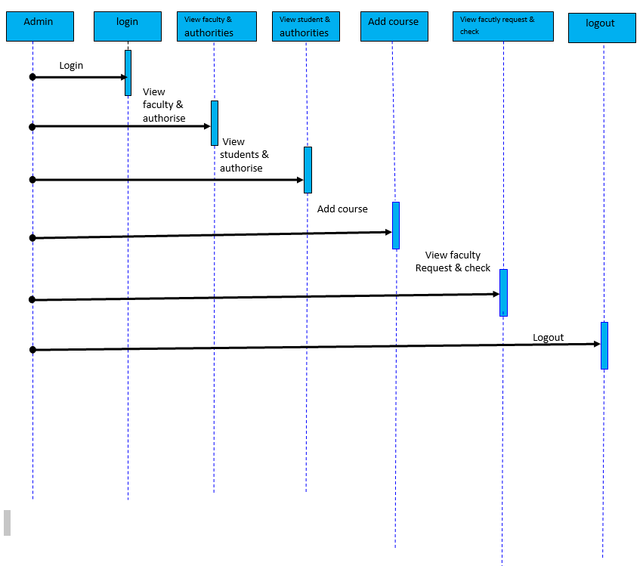

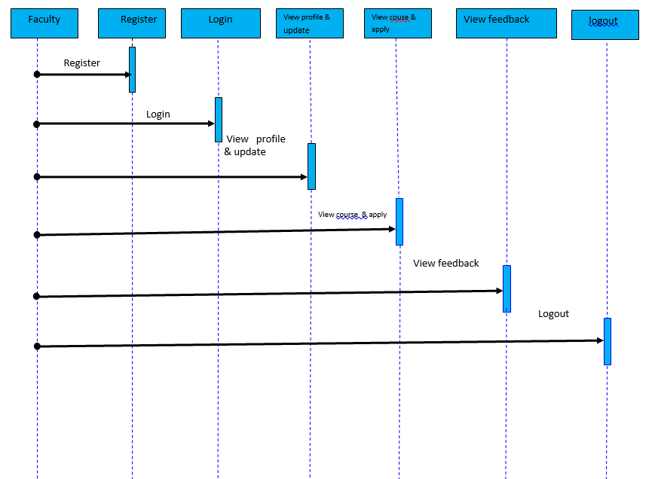

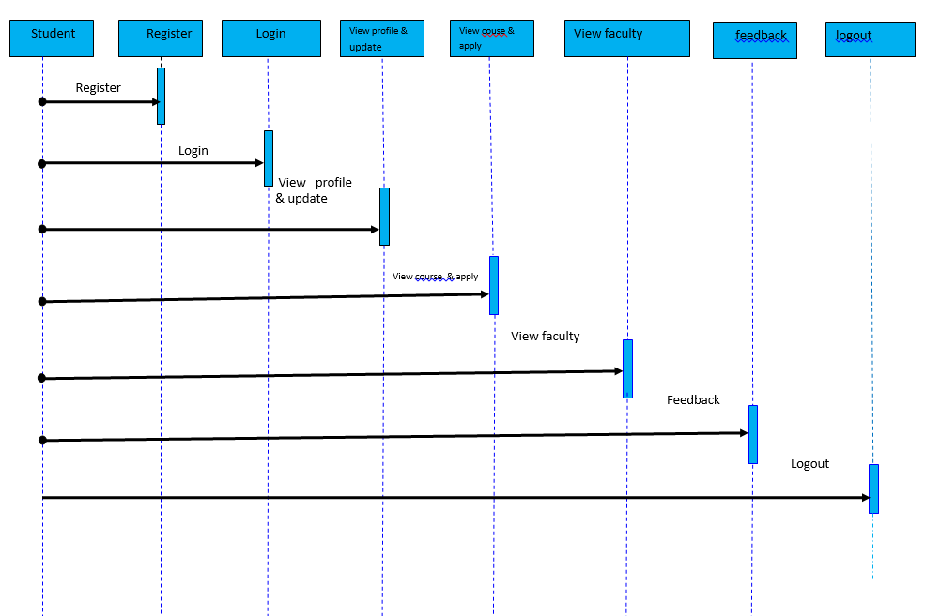

Figure 5- Sequence Diagram

4.6 Class Diagram:

Admin
Username : varchar

Password : varchar
+ login ()

+ view faculty &
Authorities ()

+ view student &
Authorities ()

+ add course ()

+ enroll faculty
Request & check ()

+ logout ()
Teacher
Username : varchar

Password : varchar
+register ()

+login ()

+view profile &
Update ()

+view course &
Apply ()

+view feedback ()

+logout ()

Student
Username : varchar

Password : varchar
+register ()

+login ()

+view profile
& update ()

+view courses
& apply ()

+feedback ()

+logout ()

Figure 7- Class Diagram

4.7 State Diagram:
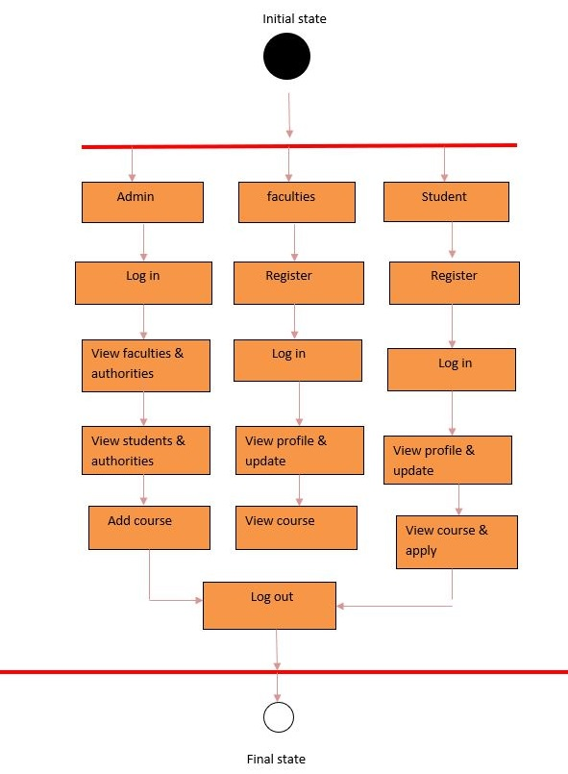
Figure 7- State Diagram

4.8 Data Dictionary
This is normally represented as the data about data. It is also termed as metadata some times which gives the data about the data stored in the database. It defines each data term encountered during the analysis and design of a new system. Data elements can describe files or the processes.
Following are some rules, which defines the construction of data dictionary entries:
  - Words should be defined to understand for what they need and not the variable need by which they may be described in the program.
  - Each word must be unique. We cannot have two definition of the same client.
  - Aliases or synonyms are allowed when two or more enters shows the same meaning. For example a vendor number may also be called as customer number.
  - A self-defining word should not be decomposed. It means that the reduction of any information in to subpart should be done only if it is really required that is it is not easy to understand directly.

Data dictionary includes information such as the number of records in file, the frequency a process will run, security factor like pass word which user must enter to get access to the information.
4.1 tbl_admin
Field | Type | Null | Key | Default | Extra
email_id | Varchar(50) | YES |  | NULL
password | varchar(50) | YES |  | NULL
otp | varchar(50) | YES |  | NULL

4.2 tbl_chatmessage
Field | Type | Null | Key | Default | Extra
sender | Varchar(50) | YES |  | NULL
receiver | varchar(50) | YES |  | NULL
message | varchar(500) | YES |  | NULL
time | timestamp | YES |  | NULL
status | varchar(1) | YES |  | NULL

  - tbl_chatstudent
Field | Type | Null | Key | Default | Extra
name | Varchar(50) | YES |  | NULL
emailid | varchar(50) | YES |  | NULL
password | varchar(10) | YES |  | NULL
status | varchar(1) | YES |  | NULL

4.4 tbl_contact
Field | Type | Null | Key | Default | Extra
name | Varchar(50) | YES |  | NULL
emailid | varchar(50) | YES |  | NULL
message | varchar(150) | YES |  | NULL

4.5 tbl_student
Field | Type | Null | Key | Default | Extra
email_id | Varchar(50) | NO | PRI | NULL
password | varchar(50) | YES |  | NULL
otp | varchar(10) | YES |  | NULL
status | varchar(10) | YES |  | NULL
name | varchar(50) | YES |  | NULL
regdno | varchar(50) | YES |  | NULL
branch | varchar(50) | YES |  | NULL
dob | varchar(50) | YES |  | NULL
gender | varchar(50) | YES |  | NULL
blood_group | varchar(50) | YES |  | NULL
mobileno | varchar(20) | YES |  | NULL
adharno | varchar(50) | YES |  | NULL
session | varchar(50) | YES |  | NULL
semester | varchar(50) | YES |  | NULL
permanent_landmark | varchar(50) | YES |  | NULL
permanent_city | varchar(50) | YES |  | NULL
permanent_district | varchar(50) | YES |  | NULL
permanent_state | varchar(50) | YES |  | NULL
permanent_pincode | varchar(50) | YES |  | NULL
permanent_country | varchar(50) | YES |  | NULL
present_country | varchar(50) | YES |  | NULL
present_landmark | varchar(50) | YES |  | NULL
present_city | varchar(50) | YES |  | NULL
present_state | varchar(50) | YES |  | NULL
present_pincode | varchar(50) | YES |  | NULL
fname | varchar(50) | YES |  | NULL
mname | varchar(50) | YES |  | NULL
photo | varchar(50) | YES |  | NULL

4.6 tbl_student_attendance
Field | Type | Null | Key | Default | Extra
attandance_date | Varchar(50) | YES |  | NULL
branch | varchar(50) | YES |  | NULL
semester | varchar(10) | YES |  | NULL
subject | varchar(10) | YES |  | NULL
emailid | varchar(50) | YES |  | NULL
regdno | varchar(50) | YES |  | NULL
status | varchar(2) | YES |  | NULL
name | varchar(50) | YES |  | NULL

4.7 tbl_studentfeedback
Field | Type | Null | Key | Default | Extra
regdno | Varchar(20) | YES |  | NULL
emailid | varchar(50) | YES |  | NULL
message | varchar(150) | YES |  | NULL

4.8 tbl_studentleave
Field | Type | Null | Key | Default | Extra
regdno | Varchar(50) | YES |  | NULL
t | varchar(20) | YES |  | NULL
f | varchar(20) | YES |  | NULL
status | varchar(2) | YES |  | NULL
emailid | Varchar(50) | YES |  | NULL
message | Varchar(150) | YES |  | NULL

4.9 tbl_subject
Field | Type | Null | Key | Default | Extra
subjectid | Varchar(50) | YES |  | NULL
subjectname | varchar(50) | YES |  | NULL
teacherregdno | varchar(50) | YES |  | NULL
semester | varchar(50) | YES |  | NULL
branch | Varchar(50) | YES |  | NULL

4.10 tbl_teacher
Field | Type | Null | Key | Default | Extra
emailid | Varchar(50) | NO | PRI | NULL
password | varchar(50) | YES |  | NULL
otp | varchar(10) | YES |  | NULL
status | varchar(10) | YES |  | NULL
name | Varchar(50) | YES |  | NULL
fname | Varchar(50) | YES |  | NULL
mname | Varchar(50) | YES |  | NULL
regdno | Varchar(10) | YES |  | NULL
joindate | Varchar(20) | YES |  | NULL
dob | Varchar(15) | YES |  | NULL
gender | Varchar(10) | YES |  | NULL
bloodgroup | Varchar(5) | YES |  | NULL
mobileno | Varchar(12) | YES |  | NULL
adhaarno | Varchar(20) | YES |  | NULL
department | Varchar(50) | YES |  | NULL
qualification | Varchar(30) | YES |  | NULL
permanent_landmark | Varchar(50) | YES |  | NULL
permanent_city | Varchar(50) | YES |  | NULL
permanent_district | Varchar(50) | YES |  | NULL
permanent_state | Varchar(50) | YES |  | NULL
permanent_pincode | Varchar(10) | YES |  | NULL
permanent_country | Varchar(50) | YES |  | NULL
present_country | Varchar(50) | YES |  | NULL
present_landmark | Varchar(50) | YES |  | NULL
present_city | Varchar(50) | YES |  | NULL
present_district | Varchar(50) | YES |  | NULL
present_state | Varchar(50) | YES |  | NULL
present_pincode | Varchar(10) | YES |  | NULL
photo | Varchar(50) | YES |  | NULL

4.11 tbl_teacher_attendance
Field | Type | Null | Key | Default | Extra
attandance_date | Varchar(50) | YES |  | NULL
branch | varchar(50) | YES |  | NULL
semester | varchar(50) | YES |  | NULL
subject | varchar(50) | YES |  | NULL
emailid | varchar(50) | YES |  | NULL
regdno | varchar(50) | YES |  | NULL
status | varchar(2) | YES |  | NULL
name | varchar(50) | YES |  | NULL

4.12 tbl_teacherfeedback
Field | Type | Null | Key | Default | Extra
regdno | Varchar(20) | YES |  | NULL
emailid | varchar(50) | YES |  | NULL
message | varchar(150) | YES |  | NULL

4.-13 tbl_teacherleave
Field | Type | Null | Key | Default | Extra
regdno | Varchar(50) | YES |  | NULL
t | varchar(20) | YES |  | NULL
f | varchar(20) | YES |  | NULL
status | varchar(2) | YES |  | NULL
emailid | Varchar(50) | YES |  | NULL
message | Varchar(150) | YES |  | NULL

CHAPTER – 5
Coding

In computer science code is any collection of statements or declaration written in sum human readable computer programming language. Code allows the programmer to communicate with the computer using reserved number of instruction.
The code which constitutes a program is usually held in one or more text file sometimes stored in databases as stored procedure and may also appear as code snippets printed in book or media. A large collection of code files may be organized into a directory tree in which case it may also be known as a code tree.
A computer programmer’s code is the collection of files needed to convert from human readable form tool some kind of computer executable form the code may be converted into an executable file by compiler or executed on the fly from the human readable form with the aid of an interpreter. The code based of programming project is the larger collection of all the source code of all the computer programs which make up the project.
We have discussed here some special codes, which play an important part in our project.

adminVerify.jsp
<%@ page language="java" contentType="text/html; charset=ISO-8859-1"
pageEncoding="ISO-8859-1"%>
<!DOCTYPE html>
<html>
<head>
<meta charset="ISO-8859-1">
<title>Insert title here</title>
</head>
<body>
<%
String emailid = request.getParameter("emailid");
%>
<h1>Verify OTP</h1>
<form action="sms.controller.VerifyAdminOTP" method="post">
<input type="hidden" name="emailid" value="<%=emailid%>"> OTP
: <input type="text" name="otp"><br><input type="submit"
value="Verify">
</form>
</body>
</html>
adminAttendance.jsp
<!DOCTYPE html>
<%@page import="java.util.Iterator"%>
<%@page import="sms.model.StudentDao"%>
<%@page import="sms.db.Student"%>
<%@page import="java.util.ArrayList"%>
<html lang="en">
<head>
<title>Student Attendance</title>
<meta charset="UTF-8">
<meta name="viewport" content="width=device-width, initial-scale=1">
<!--===============================================================================================-->
<link rel="icon" type="image/png" href="images/icons/favicon.ico" />
<!--===============================================================================================-->
<link rel="stylesheet" type="text/css"
href="fonts/fonts/font-awesome-4.7.0/css/font-awesome.min.css">
<!--===============================================================================================-->
<link rel="stylesheet" type="text/css"
href="vendor2/vendor/animate/animate.css">
<!--===============================================================================================-->
<link rel="stylesheet" type="text/css"
href="vendor2/vendor/select2/select2.min.css">
<!--===============================================================================================-->
<link rel="stylesheet" type="text/css"
href="vendor2/vendor/perfect-scrollbar/perfect-scrollbar.css">
<!--===============================================================================================-->
<link rel="stylesheet" type="text/css" href="css/css/main.css">
<!--===============================================================================================-->

<div class="limiter">
<div class="container-table100">
<div class="wrap-table100">
<div class="table">
<form action="sms.controller.AdminStudentAttendance" method="post">
<div class="row header">
<div class="cell">
Date: <input type="date" name="attendancedate">
</div>
<div class="cell">
Branch: <select name="branch">
<option value="CSE">CSE</option>
<option value="Civil">Civil</option>
<option value="MEC">ME</option>
<option value="EEE">EEE</option>
<option value="EE">EE</option>
</select>
</div>
<div class="cell">
Semester: <select name="semester">
<option value="1st Semester">1st</option>
<option value="2nd Semester">2nd</option>
<option value="3rd Semester">3rd</option>
<option value="4th Semester">4th</option>
<option value="5th Semester">5th</option>
<option value="6th Semester">6th</option>
<option value="7th Semester">7th</option>
<option value="8th Semester">8th</option>
</select>
</div>
<div class="cell">
Subject: <select name="subject">
<option value="Java">Java</option>
</select>
</div>
<div class="cell">
<input type="submit" value="Submit">
</div>
</div>
</form>
</div>
</div>
</div>
</div>

<!--===============================================================================================-->
<script src="vendor2/vendor/jquery/jquery-3.2.1.min.js"></script>
<!--===============================================================================================-->
<script src="vendor2/vendor/bootstrap/js/popper.js"></script>
<script src="vendor2/vendor/bootstrap/js/bootstrap.min.js"></script>
<!--===============================================================================================-->
<script src="vendor2/vendor/select2/select2.min.js"></script>
<!--===============================================================================================-->
<script src="js/js/main.js"></script>
</body>
</html>

Admin.java
package sms.db;

public class Admin {
private String emailid;
private String password;
private String otp;

public String getEmailid() {
return emailid;
}

public void setEmailid(String emailid) {
this.emailid = emailid;
}

public String getPassword() {
return password;
}

public void setPassword(String password) {
this.password = password;
}

public String getOtp() {
return otp;
}

public void setOtp(String otp) {
this.otp = otp;
}

}
AddMessage.java
package sms.controller;

import java.io.IOException;
import java.io.PrintWriter;
import java.sql.Timestamp;

import javax.servlet.ServletException;
import javax.servlet.annotation.WebServlet;
import javax.servlet.http.HttpServlet;
import javax.servlet.http.HttpServletRequest;
import javax.servlet.http.HttpServletResponse;
import javax.servlet.http.HttpSession;

import sms.db.ChatMessage;
import sms.model.ChatMessageDao;

/**
* Servlet implementation class AddMessage
*/
@WebServlet("/sms.controller.AddMessage")
public class AddMessage extends HttpServlet {

protected void doPost(HttpServletRequest request, HttpServletResponse response)
throws ServletException, IOException {

response.setContentType("text/html");
PrintWriter out = response.getWriter();
HttpSession session = request.getSession();
String sender = (String) session.getAttribute("emailid");
String receiver = (String) session.getAttribute("receiverEmailid");
String message = request.getParameter("message");
System.out.println(message);
System.out.println(receiver);
System.out.println(sender);

Timestamp time = new Timestamp(System.currentTimeMillis());

ChatMessage msg = new ChatMessage();

msg.setMessage(message);
msg.setReceiver(receiver);
msg.setSender(sender);
msg.setTime(time);
int status = ChatMessageDao.addMessage(msg);
if (status > 0) {
response.sendRedirect("chatPage.jsp");
}

}

}
AdminLogout.java
package sms.controller;
import java.io.IOException;
import javax.servlet.ServletException;
import javax.servlet.annotation.WebServlet;
import javax.servlet.http.HttpServlet;
import javax.servlet.http.HttpServletRequest;
import javax.servlet.http.HttpServletResponse;
import javax.servlet.http.HttpSession;

/**
* Servlet implementation class AdminLogout
*/
@WebServlet("/sms.controller.AdminLogout")
public class AdminLogout extends HttpServlet {

protected void doGet(HttpServletRequest request, HttpServletResponse response)
throws ServletException, IOException {
HttpSession session = request.getSession();
session.invalidate();
response.sendRedirect("index.jsp?msg=Logout Successful");
}

}

CHAPTER – 6

Testing

8.1. Introduction
Software testing is a critical element of software quality assurance and represents the ultimate review of specification, design and coding. In fact, testing is the one step in the software engineering process that could be viewed as destructive rather than constructive.
A strategy for software testing integrates software test case design methods into a well-planned series of steps that result in the successful construction of software. Testing is the set of activities that can be planned in advance and conducted systematically. The underlying motivation of program testing is to affirm software quality with methods that can economically and effectively apply to both strategic to both large and small-scale systems.

8.1.1Testing techniques and testing strategies used along with the test case Designs and test reports.

The software engineering process can be viewed as a spiral. Initially system engineering defines the role of software and leads to software requirement analysis where the information domain, functions, behavior, performance, constraints and validation criteria for software are established. Moving inward along the spiral, we come to design and finally to coding. To develop computer software we spiral in along streamlines that decrease the level of abstraction on each turn.
A strategy for software testing may also be viewed in the context of the spiral. Unit testing begins at the vertex of the spiral and concentrates on each unit of the software as implemented in source code. Testing progress by moving outward along the spiral to integration testing, where the focus is on the design and the construction of the software architecture. Talking another turn on outward on the spiral we encounter validation testing where requirements established as part of software requirements analysis are validated against the software that has been constructed. Finally we arrive at system testing, where the software and other system elements are tested as a whole.

UNIT TESTING

MODULE TESTING

SUB-SYSTEM TESING

SYSTEM TESTING

ACCEPTANCE TESTING
Component Testing
Integration Testing
User Testing

Figure-8 Testing Types

8.1.2. Unit Testing
Unit testing focuses verification effort on the smallest unit of software design, the module. The unit testing we have is white box oriented and some modules the steps are conducted in parallel.

1. WHITE BOX TESTING
This type of testing ensures that
- All independent paths have been exercised at least once
- All logical decisions have been exercised on their true and false sides
- All loops are executed at their boundaries and within their operational bounds
- All internal data structures have been exercised to assure their validity.
To follow the concept of white box testing we have tested each form .we have created independently to verify that Data flow is correct, All conditions are exercised to check their validity, All loops are executed on their boundaries.
2. BASIC PATH TESTING
Established technique of flow graph with Cyclomatic complexity was used to derive test cases for all the functions. The main steps in deriving test cases were:
Use the design of the code and draw correspondent flow graph.
Determine the Cyclomatic complexity of resultant flow graph, using formula:
V (G) =E-N+2 or
V (G) =P+1 or
V (G) =Number Of Regions
Where V (G) is Cyclomatic complexity,
E is the number of edges,
N is the number of flow graph nodes,
P is the number of predicate nodes.
Determine the basis of set of linearly independent paths.

3. CONDITIONAL TESTING
In this part of the testing each of the conditions were tested to both true and false aspects. And all the resulting paths were tested. So that each path that may be generate on particular condition is traced to uncover any possible errors.
4. DATA FLOW TESTING
This type of testing selects the path of the program according to the location of definition and use of variables. This kind of testing was used only when some local variable were declared. The definition-use chain method was used in this type of testing. These were particularly useful in nested statements.
5. LOOP TESTING
In this type of testing all the loops are tested to all the limits possible. The following exercise was adopted for all loops:
- All the loops were tested at their limits, just above them and just below them.
- All the loops were skipped at least once.
- For nested loops test the inner most loop first and then work outwards.
- For concatenated loops the values of dependent loops were set with the help of connected loop.
- Unstructured loops were resolved into nested loops or concatenated loops and tested as above.
Each unit has been separately tested by the development team itself and all the input have been validated.

* Manual Testing:

To start with, I have performed manual testing on the “Online Monitoring of Student Activity” Manual Testing is one of the oldest and rigorous methods of software testing. The result of the manual testing is represented in the following tables:

Test Case 1 –Login

Table 2: Manual Test Case 1 -Login

Test Unit | Test Case | Result
Log In Button | An invalid username or password entered by the user | The system generates a message “invalid  user” or “invalid password”
Log In Button | A valid username or password entered by the user | The system logs on the user and transfers him to the home page.

Test Case 2 – RegisterButton

Table 3: Manual Test Case 2 - Registration

Test Unit | Test Case | Result
Register Button | Valid fields entered by User | User registration successful
Register Button | Invalid fields entered by User | The system generates a message to enter Valid data in fields provided in UI

Login Successful

Table 3: Login Test Case I

Test Case | Login Successful
Actor | Admin/Teachers/Students
Pre-conditions | Database created, Interface created
Detailed Description | Tests if the User id is created in the database when Admin/Teachers/Students enters  appropriate information
Test Procedure | Enter required data into input fields which are username and password
Expected Results | Username will be verified in the database with the information submitted through the input fields from the interface
Expected Interface Output | Login Successful
Test Results | Passed

Login Failed

Table 4: Login Test Case II

Test Case | Login Failed
Actor | Admin/Teachers/Student
Pre-conditions | Database created, Interface created
Detailed Description | Tests if the User id is created in the database when Admin/Teachers/Student enters appropriate information
Test Procedure | Enter required data into input fields with blank or wrong username and password
Expected Results | Username will be verified in the database and displays the message  Username or Password does not match
Expected Interface  Output | Login Failed
Test Results | Passed

Teacher Registration:

Table 5: Test Case – I for Teacher Registration

Test Case | Register New User/Engineer
Actor | Admin
Pre-conditions | Database created, Interface created
Detailed Description | Test if admin can register Teacher in OMSA
Test Procedure | Click, “Register”, Input the data and information requested on interface
Expected Results | Teacher get registered to OMSA
Expected Interface Output | Your Registration Successful
Test Results | Passed

Teachers Registration Failed

Table 6: Test Case – II for Teachers Registration Failed

Test Case | Register New User (Failed as User Already exist)
Actor | Admin
Pre-conditions | Database created, Interface created
Detailed Description | Test if admin can register Teacher in OMSA
Test Procedure | Click, “Register”, Input the data and information requested on interface
Expected Results | User will not get registered to OMSA as already registered
Expected Interface Output | User already exists
Test Results | Passed

Student Registration:

Table 7: Test Case – I for Student Registration

Test Case | Register New Student
Actor | Admin
Pre-conditions | Database created, Interface created
Detailed Description | Test if admin can register Student in OMSA
Test Procedure | Click, “Register”, Input the data and information requested on interface
Expected Results | Student get registered to OMSA
Expected Interface Output | Your Registration Successful
Test Results | Passed

Student Registration Failed

Table 8: Test Case – II for Student Registration Failed

Test Case | Register New User (Failed as User Already exist)
Actor | Admin
Pre-conditions | Database created, Interface created
Detailed Description | Test if admin can register Student in OMSA
Test Procedure | Click, “Register”, Input the data and information requested on interface
Expected Results | Student will not get registered to OMSA as already registered
Expected Interface Output | Student already exists
Test Results | Passed

Give Feedback

Table 9: Test Case – I for Give Feedback

Test Case | View Complaint
Actor | Teacher / Student
Pre-conditions | Database created, Interface created
Detailed Description | Test if Teacher / Student can give feedback in OMSA
Test Procedure | Click, “Give Feedback”, present in left menu bar
Expected Results | On successful Admin can view feedback.
Expected Interface Output | Displays all the feedback at admin Dashboard.
Test Results | Passed

CHAPTER – 7
Output Screens


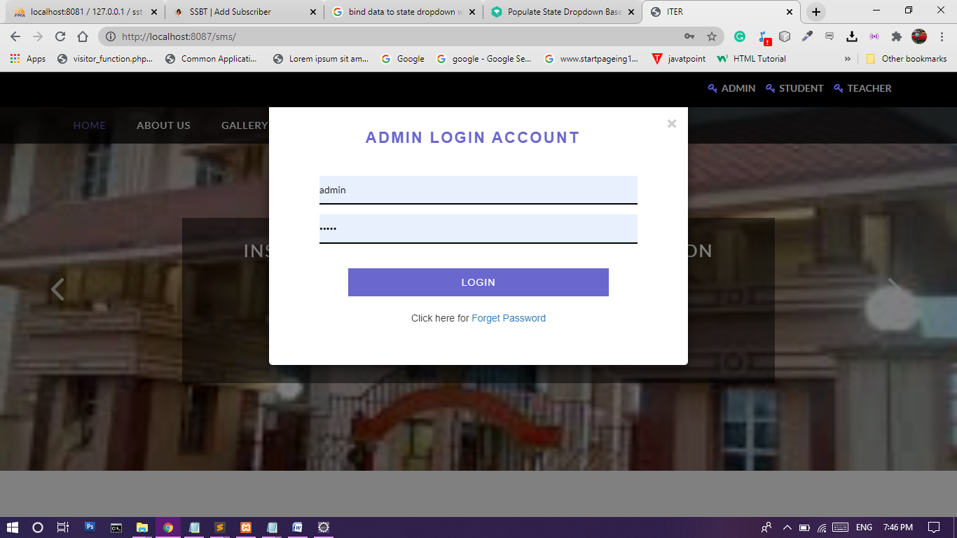

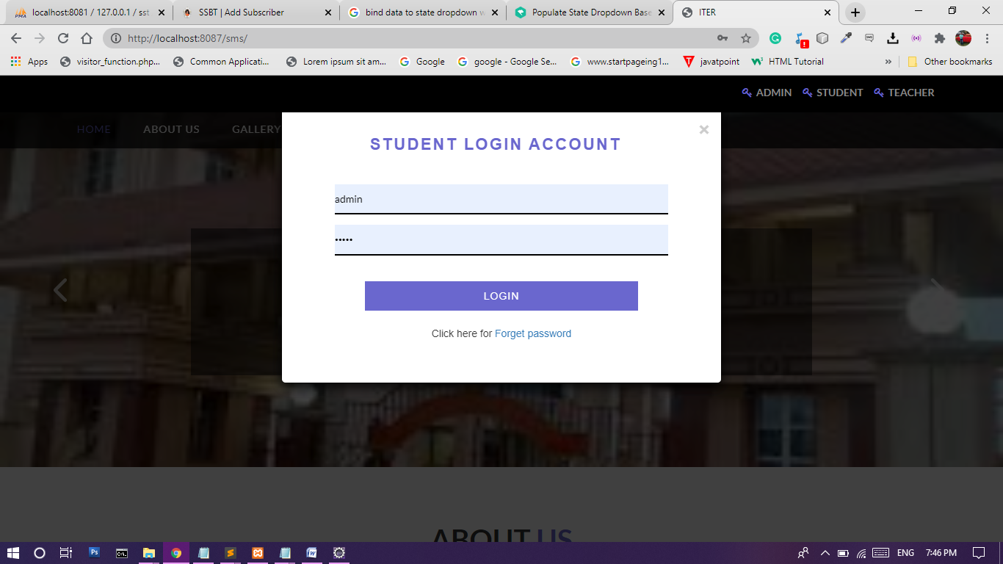
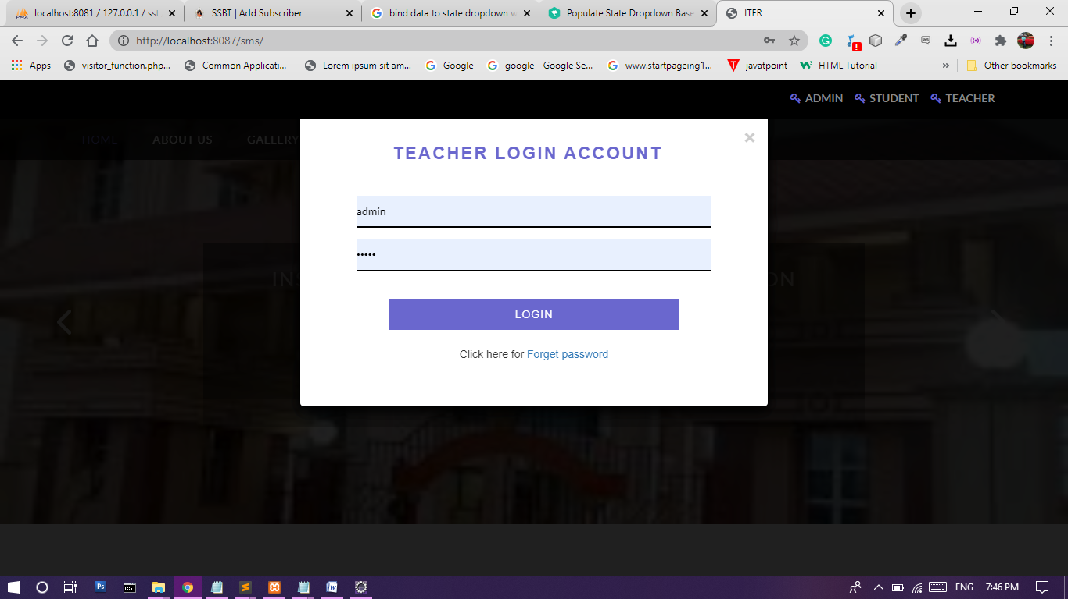
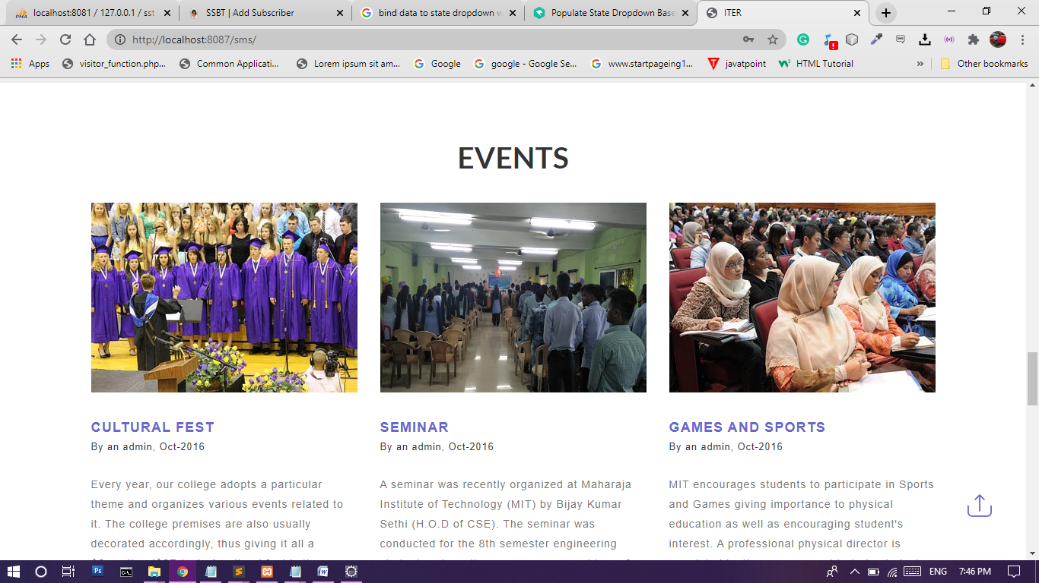
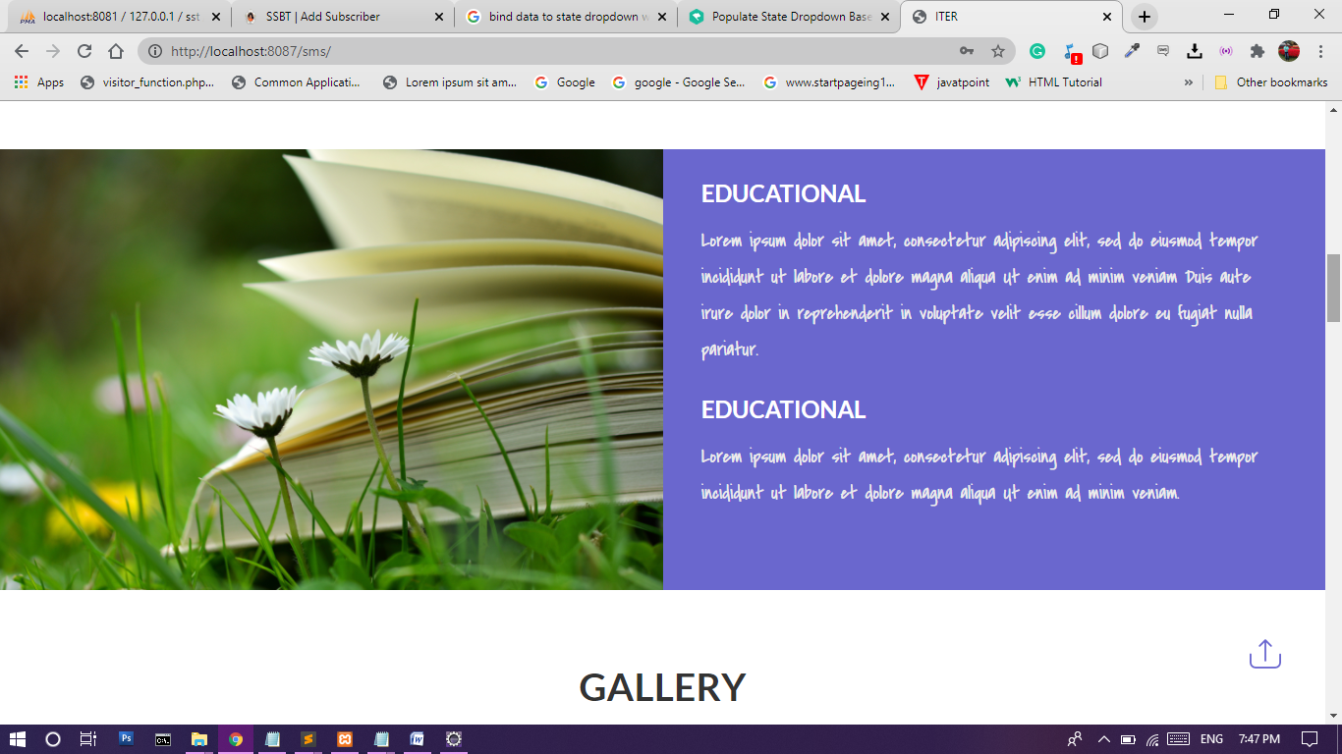

CHAPTER – 8
Conclusion and Future Scope

8.1 Conclusion :
Online Monitoring of Student Activity is very useful in an institution or in college or in universities. There is no paper work and manual file handling in this proposed system. Supervision can be done from anywhere. This project especially minimizes human effort necessary. This application is handled by the college so there is no information leak and data will be secured. Since it is a web based application anyone can use the system anywhere at any time and it is very easy to get the necessary information without the latency. It is very useful to the students to get their report on attendance and internal assessments. Parents also get benefited more since college is going to send the notification of the student via the SMS or email will be sent to get the recent activities happen in the college. Since this application will be handled by the college whenever they need any changes in an application they can make it without the upfront investment, and the system will be more secure when it is handled by the own college.
8.2 Future Scope of the Project:
The project can be used by any educational institution and the project can be enhanced subsequently by providing additional feature like accounting management, admission process automation and will became an ERP application. And our main intention is to provide this application to those educational institutions who cannot afford huge amount for other application available in the market.
CHAPTER – 9
References

- For Java installation
    - https://www.java.com/en/download/
- For MySql Database installation
    - https://dev.mysql.com/downloads/mysql/
- For Server(Apache Tomcat) installation
    - https://tomcat.apache.org/download-90.cgi
- Reference websites
    - www.javatpoint.com
    - www.w3schools.com
    - http://www.tutorialspoint.com/java/index.htm
    - https://en.wikipedia.org/wiki/Wiki
    - https://www.geeksforgeeks.org/
- Reference Books
    - Complete reference Java
    - Thinking in java
    - Java Black Book J2EE
    - Learn Java in Easy Steps
    - Complete reference Java
    - Object-Oriented Analysis &Design Using UML

